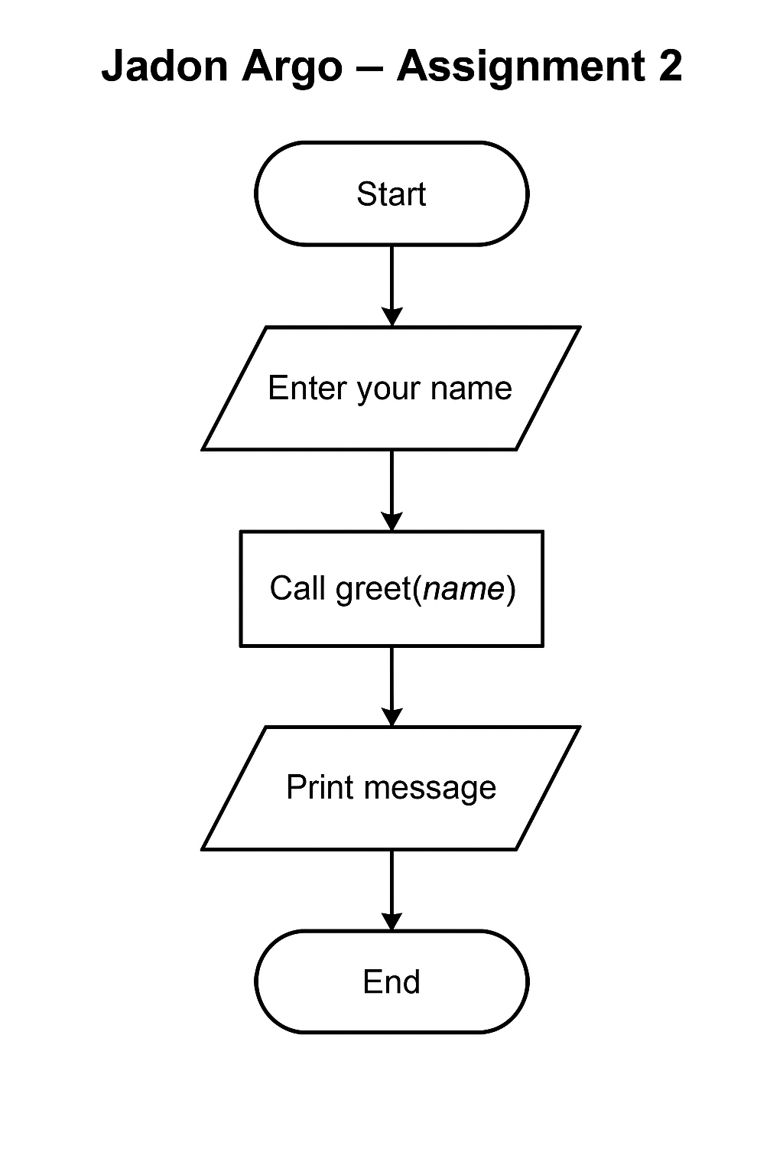

# Author: Jadon Argo

# Assignment: Module 2

# Description: This program asks for a user's name, processes it through a greeting function,

# and prints a personalized message. Includes basic error handling and logging.

def greet(name):

"""

Returns a personalized greeting message.

"""

return f"Hello, {name}!"

def main():

try:

# Ask for user input

user = input("Enter your name: ")

# Validate input is not empty

if not user.strip():

raise ValueError("Name cannot be empty.")

# Generate greeting message

message = greet(user)

# Display message

print(message)

except Exception as e:

# Output error to console

print(f"An error occurred: {e}")

# Log the error to a file

with open("error_log.txt", "a") as log:

log.write(f"Error: {e}\n")

# Program starts here

if __name__ == "__main__":

main()

I didn’t have a debugger on replit. Made this a little difficult. I had assistant that labled errors and could fix them. Might have to switch to new IDE.